**UNIVERSITI TUNKU ABDUL RAHMAN**

**LEE KONG CHIAN FACULTY OF ENGINEERING AND SCIENCE**

**UECS2344 SOFTWARE DESIGN**

**ASSIGNMENTS (Screenshot of output program code)**

**January 2024 Trimester**

|  |  |  |  |
| --- | --- | --- | --- |
| **NO.** | **STUDENT NAME** | **STUDENT ID** | **Practical Group** |
| **1.** | **Liew Chun Kin (Group Leader)** | **2103388** | **P2** |
| **2.** | **Andrew Woon Mun Hong** | **2102584** | **P4** |
| **3.** | **Gan Wei Jia** | **2102338** | **P4** |
| **4.** | **Lim Jun Hau** | **2102629** | **P2** |

Table of Contents

|  |  |  |
| --- | --- | --- |
| No | Title | Page |
| 1. | Output | 3 – 18 |

1. **Output**

**1.0 Main menu**

* 1. **Error input in Main Menu**

**2.0 Create account system**

**3.0 Login**

**3.1 Error input in Login Menu**

**4.0 Customer Menu**

**4.1 Order Item with continue**

**4.1.1 Order Item with exit**

**4.1.2 Order Option when order existed**

**4.1.4 Error input in order item**

**4.1.5 Order item has sold out**

**4.2 Edit order menu**

**4.2.1 Cancel Order**

**4.2.2 Delete or Add item menu**

**4.2.3 Add item into order**

**4.2.4 Error when add sold out item**

**4.2.5 Error input in add item menu**

**4.2.6 Delete item menu**

**4.2.7 Error input in delete item menu**

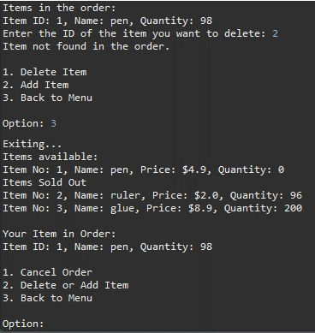

**4.2.8 Exit Menu from Delete or Add Item menu**

**4.2.9 Exit Menu from Edit Order Menu**

**4.3 Pay Bill Menu**

**4.3.1 Error number length in Pay Bill Menu**

**4.3.2 Error input in Pay Bill Menu**

**4.4 Log out to Main Menu**

**5.0 Login into Staff Menu**

**5.1 Add item into inventory**

**5.1.1 Error input with existed item no**

**5.2 Generate Report**

**5.3 Update Inventory Menu**

**5.3.1 Update item Menu**

**5.3.2 Error input in Update item Menu**

**5.3.3 Delete item successful**

**5.3.4 Wrong input in Delete item Menu**

**5.3.5 Exit Menu to Staff Menu**

**5.4 Logout to Main Menu**

**6.0 Exit to Main Menu**